RSA Implementation & Chosen Ciphertext Attack

- Introduction

This program is writen in Sagemath Python. I encourage you to download it if you haven’t it.

The purpose is to encrypt and decrypt a random strings. Moreover, we can recover the full plaintext with the chosen ciphertext attack. I will explain you how later in this report.

The only libraries use in this program is random to randomize number between to number and time to calculate the time for encryption/decryption. So to launch the program, you don’t need any other installation than python.

You need to put your text you want to encrypt in a folder named “original_plaintext.txt” in the same directory than the program.

- RSA Implementation

Firstly to understand the chosen ciphertext attack, you need to understand the basic implementation of encryption and decryption RSA.

To do this, we need to generate two keys. One public key and one private key.
The public key is used to encrypt a message and return a ciphertext.
The private key is used to decrypt the ciphertext and return a plaintext.
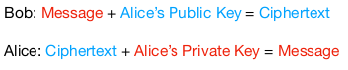

In order to generate keys, we do:
- Choose two large primes numbers (p & q)
- Compute phi/totient such that totient = (p-1) * (q-1)
- Choose a random number e such that e is coprime with totient
- Compute d such that d = e^-1 mod totient

Now the public key is e and n, the private key is d and n.

Example from the code :
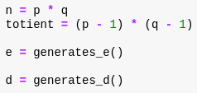

p and q are the two primes you provided.
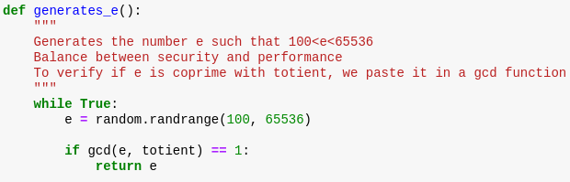
The e function :

To compute e, we choose an random number between 100 and 65536 to have a good balance between security and performance.

Then, we put this e and totient in the gcd function describe below to verify if they are coprime each other.

If they are coprime, the greatest common divisor (gcd) should be 1.
Finally, we return e.

The gcd function :
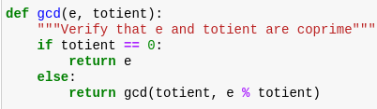

The d function :
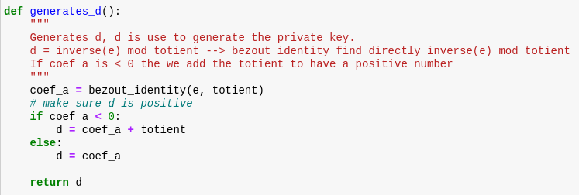

The bezout identity function to find the inverse of e :
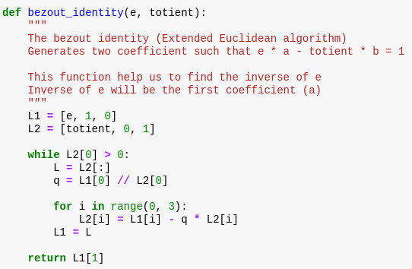

Now, we can encrypt data with the formule c = m^e mod n :
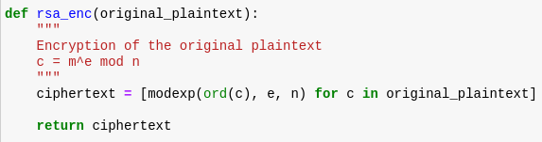

For every character in the original plaintext, we use native method pow. This method consist of (base, exp, modulus). So, if we input this :
pow(1, 2, 3) = 1^2 mod 3

After that, I write the ciphertext in a file.

Now, we can decrypt data with the formule : m = c^d mod n :
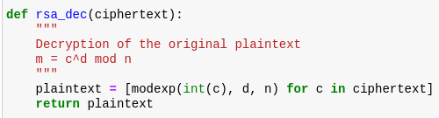

This function return me a list of ascii numbers. Si I convert every number is string equivalent with chr() and I write the plaintext in a file.

The modexp function is needed to compute x^a mod b. To do this, we need to implement a modular exponentiation using square and multiple algorithm because the power is too big to compute without simplyfing:
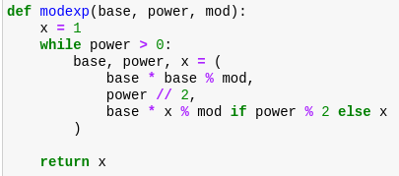

- Chosen Ciphertext Attack

To better understand how it works, take a look of this home made diagram :
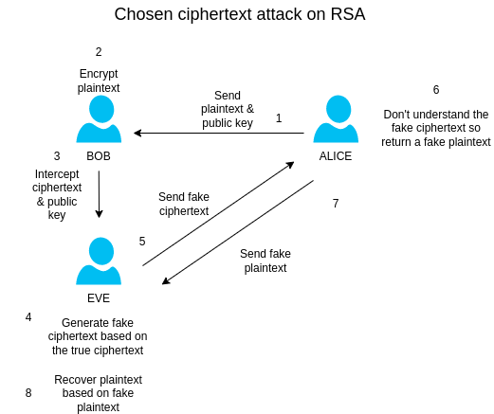

With formule, this look like this :
- To generate a fake ciphertext
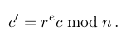

r must be a random number such that r != 1 mod n

- To recover plaintext
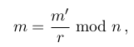

In the program, this look like this :
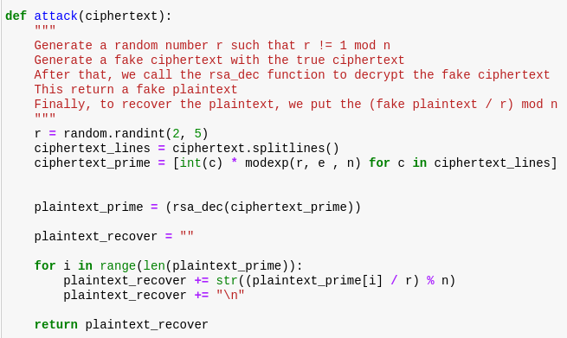
This function return a list of ascii character, we need to convert it to string with chr() method.

- Q&A

Your choices of d and e ?

To find e, I use a random number between (100, 65536) for performance purpose.
And I verify that e is coprime with totient.
For more details, look at chapter 2 function e.

To find d, I find the inverse of e modulo totient.
And if d is negative, we add totient to d.

For more details, look at chapter 2 function d.

How long does it take to do one encryption and decryption with your implementation ?

For this text : “Lorem ipsum dolor sit amet, consectetur adipiscing elit, sed do eiusmod tempor incididunt ut labore et dolore magna aliqua. Ut enim ad minim veniam, quis nostrud exercitation ullamco laboris nisi ut aliquip ex ea commodo consequat. Duis aute irure dolor in reprehenderit in voluptate velit esse cillum dolore eu fugiat nulla pariatur. Excepteur sint occaecat cupidatat non proident, sunt in culpa qui officia deserunt mollit anim id est laborum.”

It tooks me 0,014 seconds to encrypt and 2,212 seconds to decrypt.
For the attack mode, the time is more or less the same than decryption.
